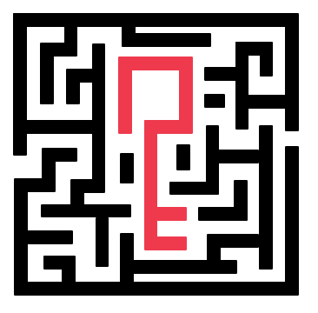

U N T I T L E D

Documentation

1. TEAM :

* Martin Mechkov - Scrum Trainer - MMMechkov19@codingburgas.bg
* Mariya ilcheva - Back End - MZIlcheva19@codingburgas.bg
* Hristo Kovachev - Back End - HPKovachev19@codingburgas.bg
* Vanina Teneva - QA Engineer - VNTeneva19@codingburgas.bg

2. ROLES :

* Scrum Trainer
* Front End
* Back End
* QA ENGINEER

3.USED PROGRAMS AND LANGUAGES

* Discord

Discord is the easiest way to talk over voice, video, and text. Talk, chat, hang out, and stay close with your friends and communities.

* Visual studio code

Visual Studio Code is a freeware source-code editor made by Microsoft. Features include support for debugging, syntax highlighting, intelligent code completion, snippets, code refactoring, and embedded Git.

* Word

Microsoft Word or MS Word (often called Word) is a graphical word processing program that users can type with. It is made by the computer company Microsoft. Its purpose is to allow users to type and save documents.

* PowerPoint

PowerPoint is a complete presentation graphics package. It gives you everything you need to produce a professional-looking presentation. PowerPoint offers word processing, outlining, drawing, graphing, and presentation management tools- all designed to be easy to use and learn.

* Adobe Illustrator CC Logo PNG Transparent &amp; SVG Vector - Freebie SupplyAdobe Illustrator

Adobe Illustrator is a professional vector-based design and drawing program. Used as part of a larger design workflow, Illustrator allows for the creation of everything from single design elements to entire compositions. Designers use Illustrator to create posters, symbols, logos, patterns, icons, etc.